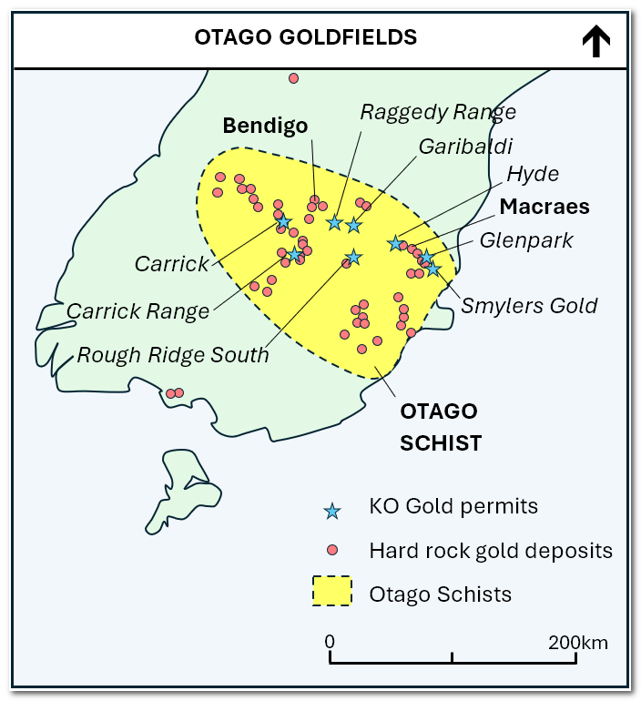
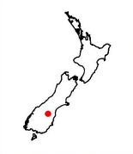
Fact Sheet
- A World-Class Gold Mining District
- KO Gold owns 5 Exploration Permits (EP) totalling 400 km2). In Quarter four 2005, 3 permits were sold and retained a 1% NSR.
- All permits are in the fertile Orogenic (Mesothermal) Gold Deposits of the Otago district South Island of New Zealand
- All permits have similar geological environments to historical and current major gold producers and developers in the district:
  - 1.4Moz MRE, >5Moz produced, Macraes Gold Project (Oceana Gold Corp TSE: OGC) Hyde Macraes Shear Zone (HMSZ)
  - 2.3Moz MRE Bendigo Project (Santana Minerals Ltd NZE: SMI) Rise and Shine Shear Zone (RSSZ)


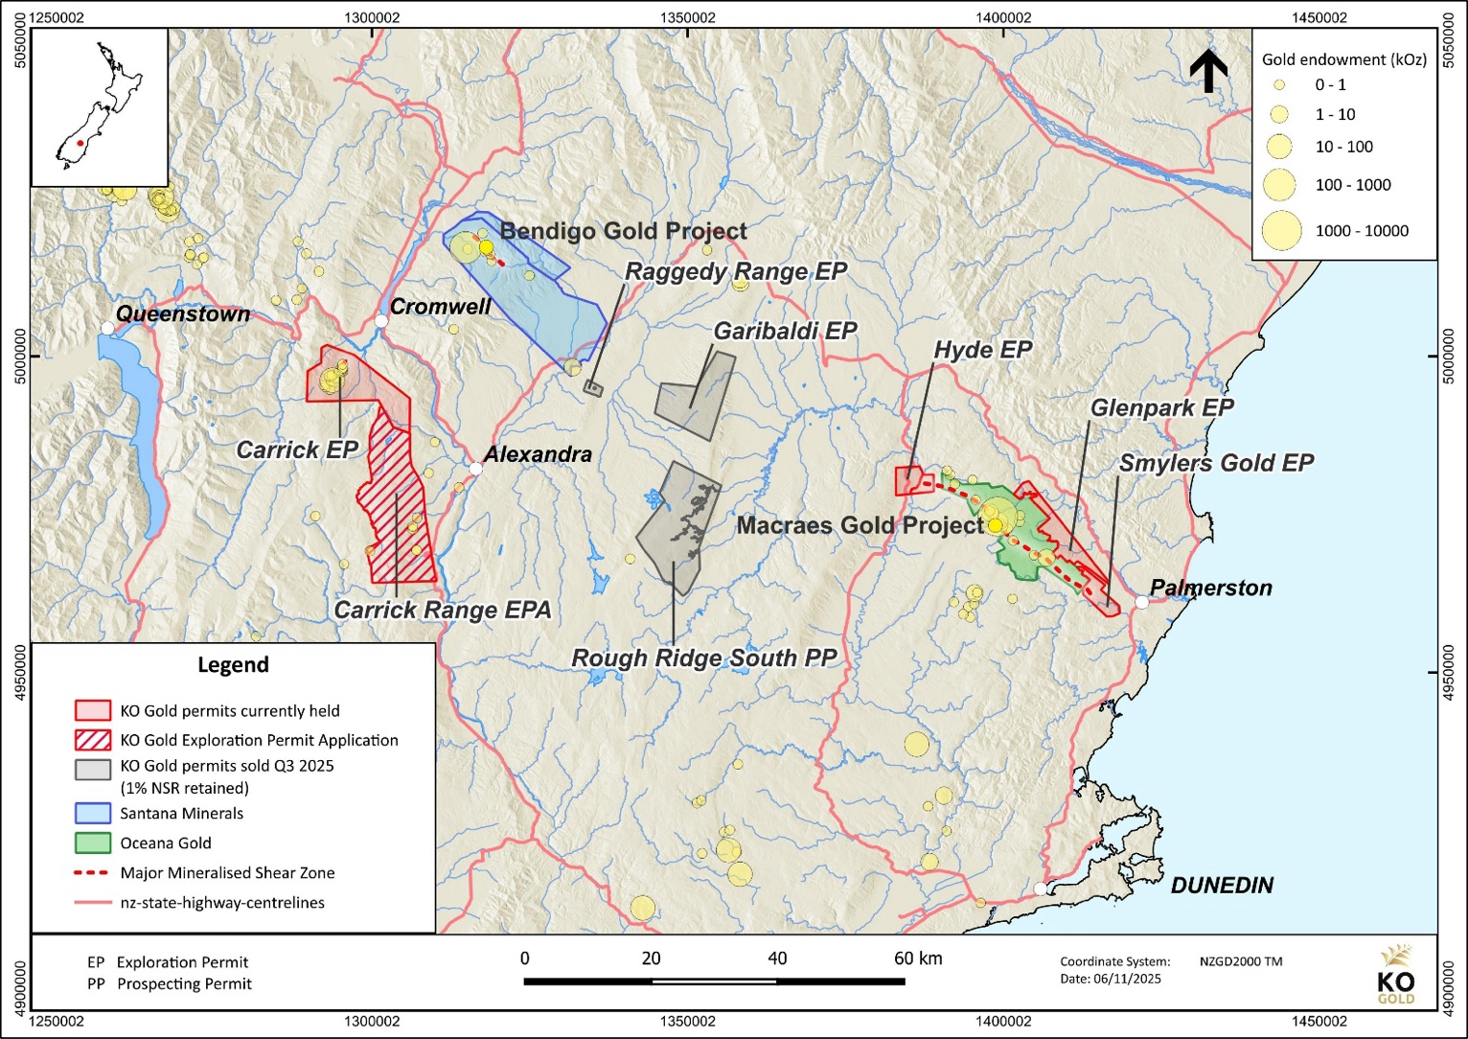
Carrick: Drilling down-dip extensions of previous intersections
Antimony
Carrick
Gold Field
Santana Minerals - 2.3 Moz Au
Indicated & Inferred Resource
Glenpark:
Drilling down dip extension of Macraes deposit
Smylers:
Expanding drilling along HMSZ and confirming mineralized zones
OceanaGold – 1.4 Moz Au
Measured & Indicated Resource

Figure 1: Permit Map
- 4 permits (Carrick, Hyde, Smylers Gold and Glenpark projects) have drill ready targets
- Land ownership largely private with limited Department of Conservation land (Carrick and Carrick Range only)
- Glenpark and Smylers Gold exploration permits (EP) have high-grade gold potential based on drilling completed by KO Gold and Hardie Pacific along strike and down dip of the Hyde Macraes Shear Zone
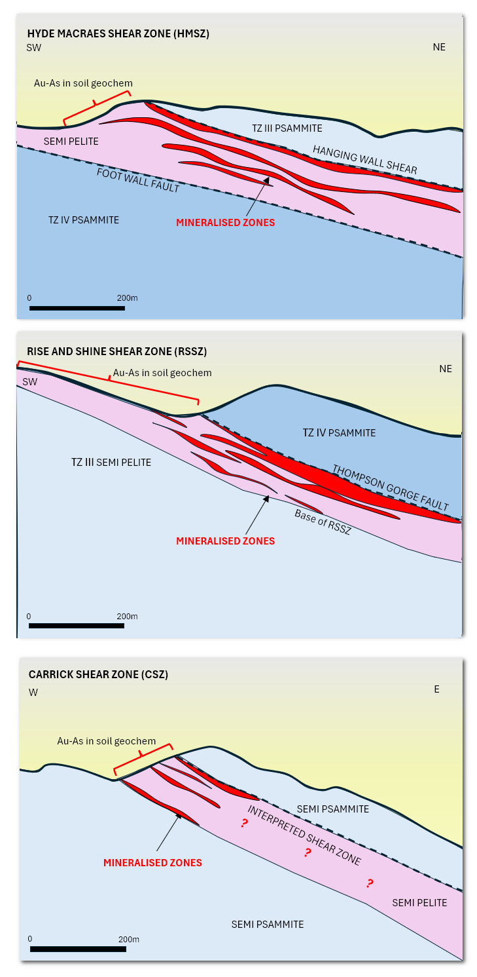



- KO Gold permits have similar host rock and mineralisation styles, and similar down dip potential to Bendigo and Macraes gold projects (Figure 2)

- Hyde Project covers potential western extension to the Hyde Macraes Shear Zone immediately west of Macraes Mine

- Carrick Project 24koz historically mined up to 1920’s. Drilling since 1980’s has returned intercepts similar to early Macraes and Bendigo project grades and widths:

- Smylers Gold Project – 4km of HMSZ confirmed by mapping, soil sampling, geophysics and drilling. Drill hole intercepts:
  - 1 m at 10.1 g/t Au (Home Reef South)
  - 3 m at 2.5 g/t Au (Pipeline South)
  - 9 m at 1 g/t Au and (Kensington)
  - 3 m at 2.4 g/t Au (Kensington)
  - 5 m at 3.4 g/t Au including 1 m at 8.3 g/t Au (Williams)
  - 2 m at 4.7 g/t Au (Williams)
  - 7 m at 1 g/t Au (Hoopers)

- Glenpark Project - Down dip drill targets on the Hyde Macraes Shear Zone

Figure 2: Cross Sections comparing Macraes, Rise and Shine and Carrick shear zone geology
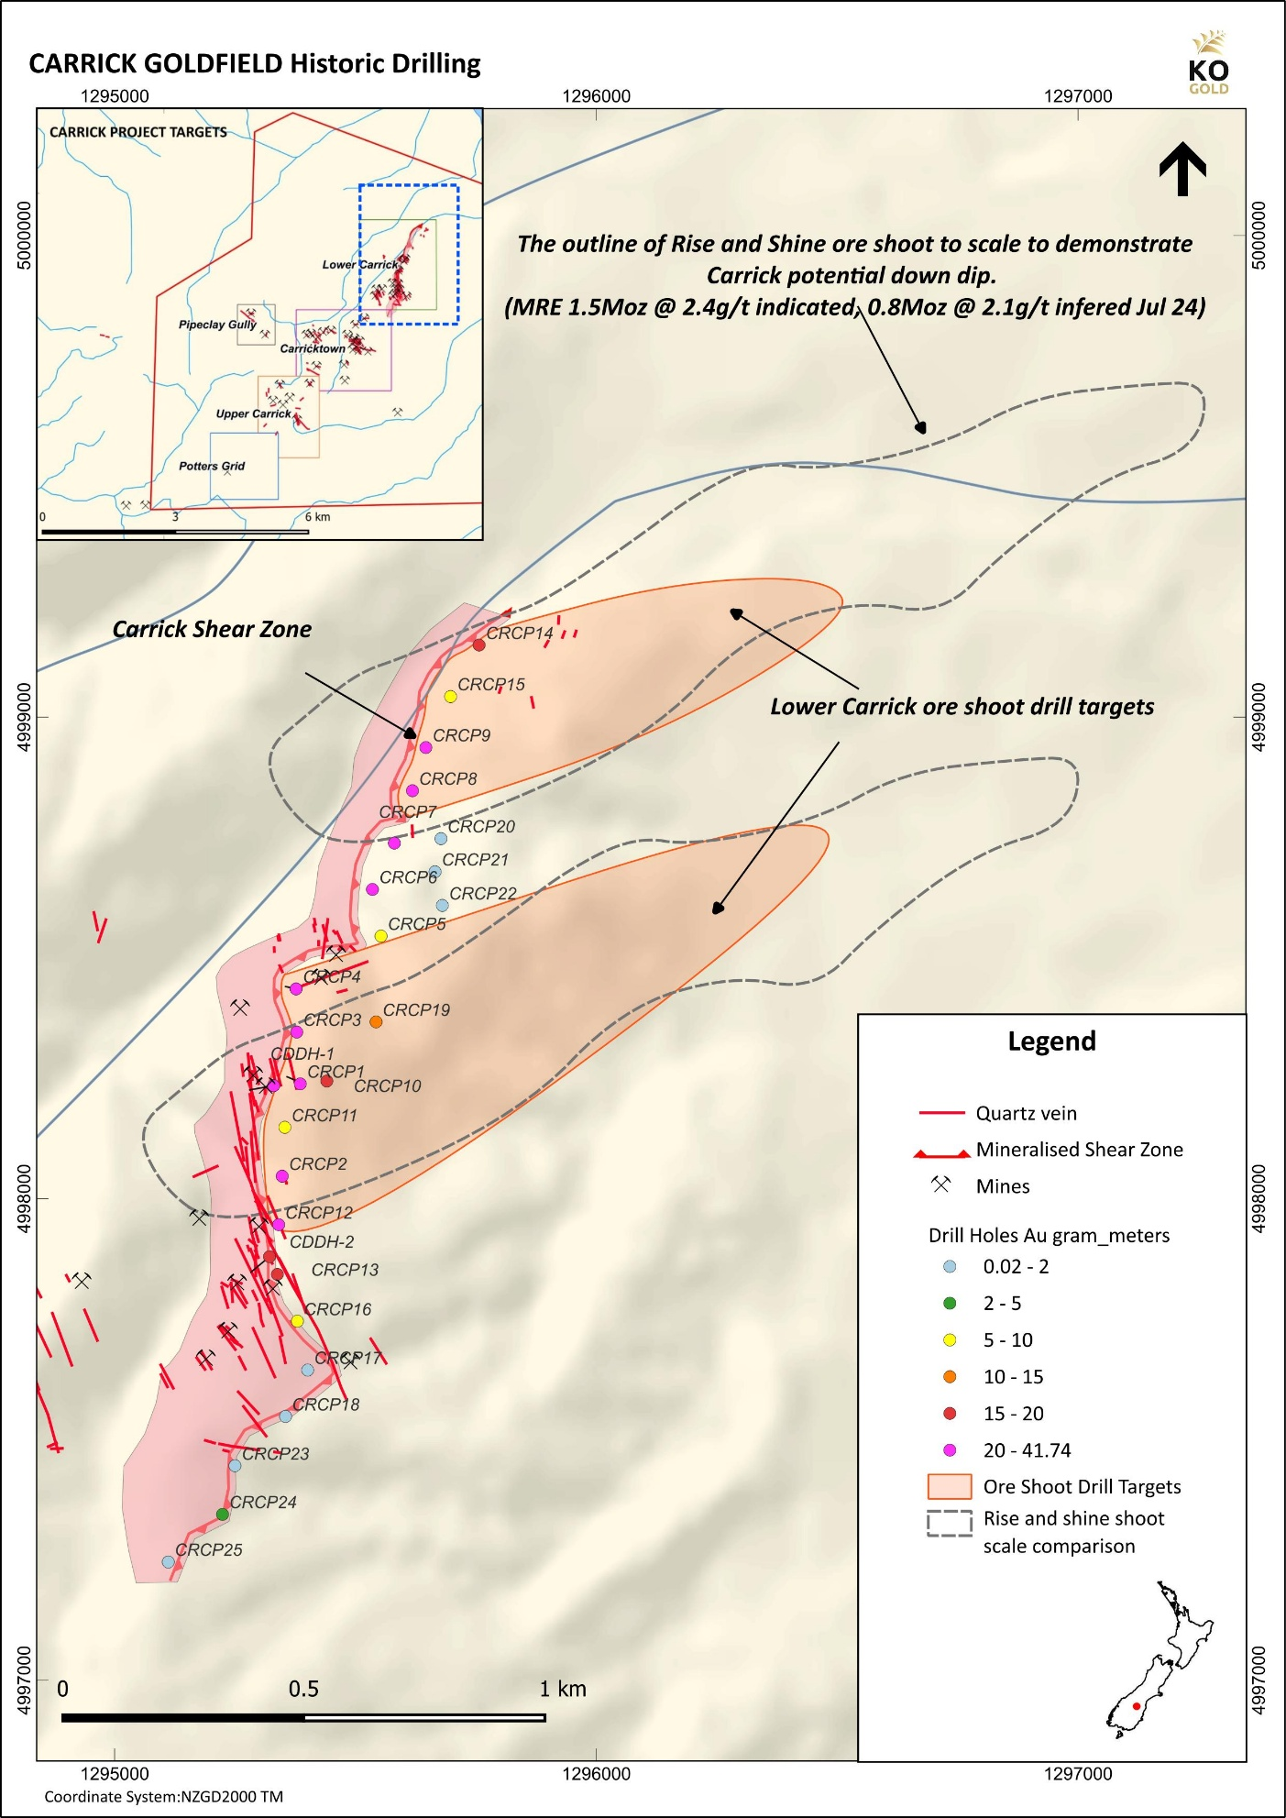
Figure 3: Lower Carrick Drill Target and Rise and Shine comparison

Table 1: Carrick Historic Drill Hole Intercepts
Project | DHID | Type | From | To | Intercept | g/t Au | Prospect
Carrick | CDDH-1 | DDH | 1 | 56 | 55.0 | 0.47 | Lower Carrick
Carrick | CRCP-1 | RC | 94 | 106 | 12.0 | 1.13 | Lower Carrick
Carrick | CRCP-3 | RC | 27 | 44 | 17.0 | 1.07 | Lower Carrick
Carrick | CRCP-7 | RC | 36 | 46 | 10.0 | 1.28 | Lower Carrick
Carrick | CRB003 | RAB | 2 | 14 | 12.0 | 2.98 | Carricktown
Carrick | Incl |  | 8 | 10 | 2.0 | 14.50 | Carricktown
Carrick | CRB10 | RAB | 0 | 4 | 4.0 | 7.44 | Carricktown
Carrick | CRB11 | RAB | 22 | 24 | 2.0 | 14.48 | Carricktown
Carrick | CRB16 | RAB | 4 | 8 | 4.0 | 3.07 | Carricktown
Carrick | PCRC14 | RC | 16 | 22 | 6.0 | 1.51 | Upper Carrick
Carrick | Incl |  | 18 | 20 | 2.0 | 3.68 | Upper Carrick
Carrick | PCRC15 | RC | 24 | 26 | 2.0 | 0.50 | Upper Carrick
Carrick | PCRC16 | RC | 6 | 8 | 2.0 | 0.60 | Upper Carrick
Carrick | PCRC03 | RC | 24 | 58 | 34.0 | 0.34 | Potters
Carrick | And |  | 74 | 78 | 4.0 | 0.35 | Potters
Carrick | And |  | 88 | 92 | 4.0 | 0.33 | Potters
Carrick | PCRC04 | RC | 2 | 10 | 8.0 | 0.40 | Potters
Carrick | And |  | 56 | 60 | 4.0 | 1.19 | Potters
Carrick | PCRC06 | RC | 58 | 68 | 10.0 | 0.76 | Potters
Carrick | Incl |  | 58 | 62 | 4.0 | 1.49 | Potters
Carrick | PCRC13 | RC | 36 | 44 | 8.0 | 0.49 | Potters
Carrick | incl |  | 36 | 38 | 2.0 | 1.19 | Potters
Carrick | PCRC14 | RC | 16 | 22 | 6.0 | 1.51 | Potters
Carrick | incl |  | 18 | 20 | 2.0 | 3.68 | Potters

Corporate Snapshot
- KO Gold listed on CSE under ”KOG"
- 0.27 CAD (Share price as of January 14, 2026)

Market Capitalization

Total issued and outstanding shares: | 26,888,504
Options outstanding: | 1,950,000
Warrants outstanding: exercisable at 40 cents and expiring Jan 10, 2027 | 3,363,772
Fully diluted shares outstanding: | 32,202,276
Current Market Capitalization: | $7.3M

Contact
KO Gold Inc. Suite 802 - Sun Tower, 1550 Bedford Highway, Bedford, NS B4A 1E6 Canada
Greg Isenor President & CEO
Website: kogoldnz.com
Email: gpisenor@kogoldnz.com
Phone: +1 (902) 832-5555

